|  |  |
| --- | --- |
| Team ID | PNT2022TMID48636 |
| PROJECT NAME | INVENTORY MANAGEMENT SYSTEM FOR RETAILERS |

**Create IBM Cloud account:**

**TEAM LEAD( N.S.Sai Prasanthy):**

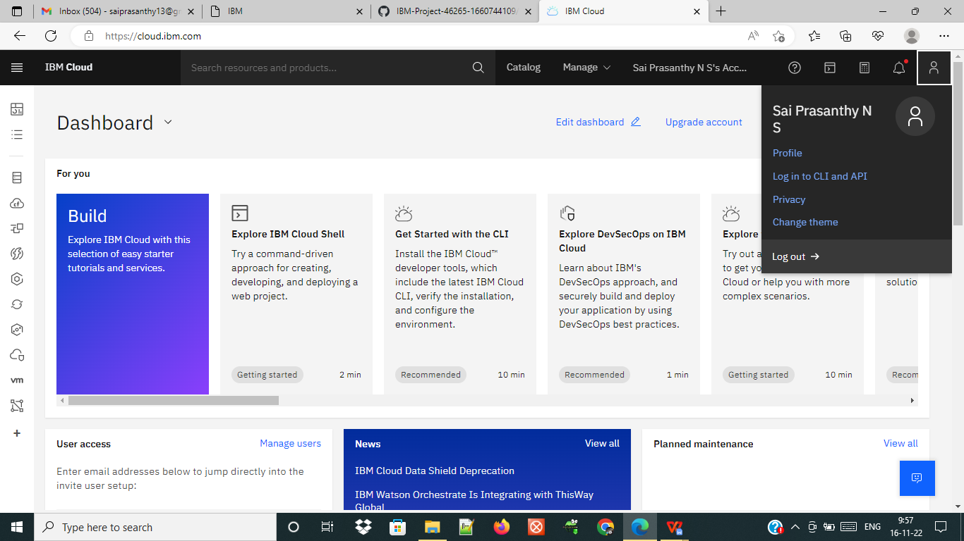

**TEAM MEMBER 1( K.SUBHASHINI):**

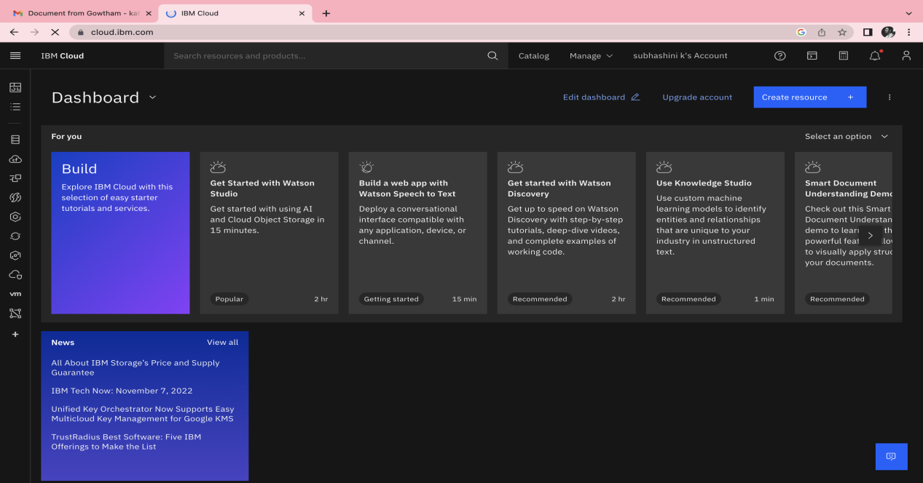

**TEAM MEMBER 2( P.SELVANJALI):**

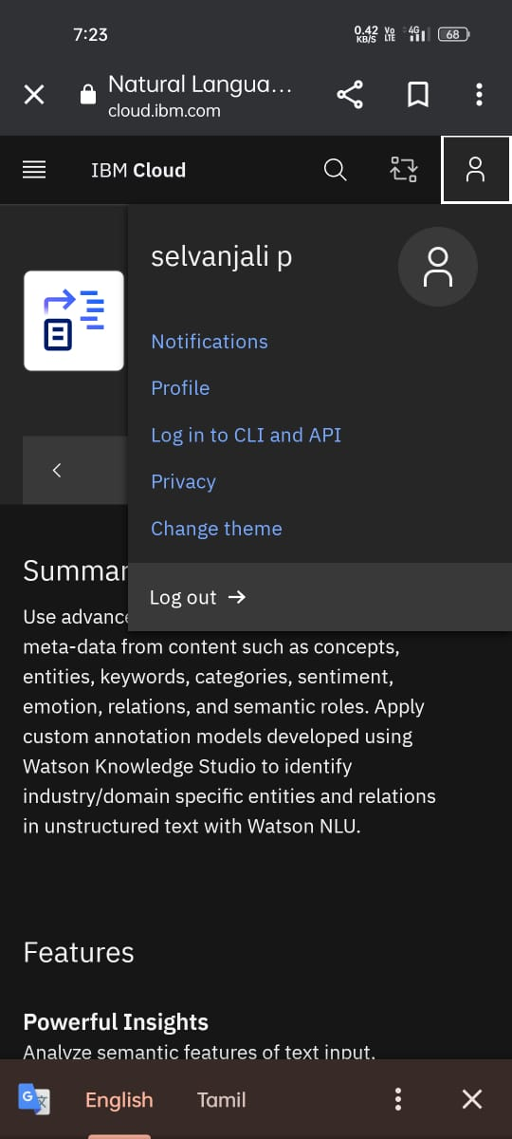

**TEAM MEMEBER 3(R.JANANI):**

